**IS THIS A CAT?**

Darrell Bryan

Fanshawe College

Phil-1006: Great Philosopher

Dr. Nicholas McGinnis

Feb 13, 2021

**IS THIS A CAT?**

The great Philosopher Plato spoke of this ‘Theory of Forms’, a theory in which tried to solve the question of ‘What makes a thing the kind of thing it is’. How can humans look at something new and categorize the item into similar groupings? On top of this, the theory tries to unravel the process of learning, how are humans able to learn anything at all? In doing so, Plato denounces the belief that humans are born as a blank slate, and instead believes our souls are eternal, forever carrying fragments of knowledge in which we simply must recall.

**Theory of Forms**

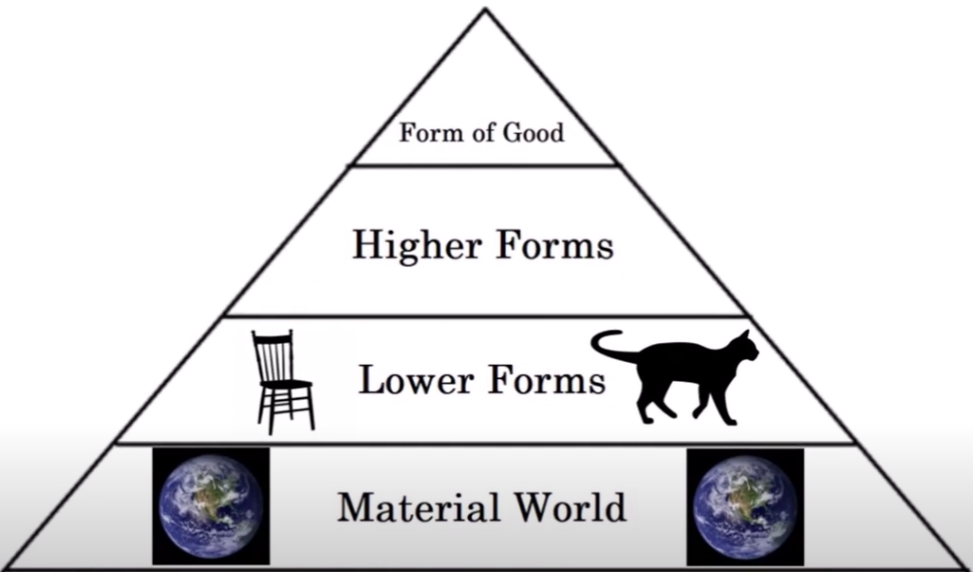According to Plato, all things derive from the ‘Form of Good’, everything that could ever be is just an incomplete shard of this greater good. A step down are the higher forms, which are the intangible characteristics of things like pure beauty, justice and good. Again, many traits can be attuned to these higher forms, but no one characteristic can define them. Below that we have the lower forms, these forms are the concept of the perfect version of a material object; as in, one perfect entity with many imperfect instances. To Plato these incomplete instances are what we call life, the material world simply being just a shadow of imperfect attempts at lower forms, and humans being imperfect attempts at higher forms.

**What’s the problem?**

With this theory, Plato is trying to tackle one of the great questions of philosophy, the problem of Universals: Does the concept inform what we see, or does what we see inform the concept? The Theory of forms favours the idea that, if from birth we can instinctively know the concept of good then we must have already had prior knowledge of that form of good. Furthermore, our lives are simply recalling knowledge dimmed by the trauma of birth, nothing completely new can be learned, because any learning is only just understanding the already known form. This is all a direct contrary to our current view on education, where we are born a blank slate and can obtain any knowledge through hard work and dedication. Plato rebukes this notion and states that if we were born in a state of Tabula rasa, we would remain as blank slates.

Of similar importance is how humans interpret the different forms. Plato speculates this is done on a mental scale, as in when we see something our brains first search for an initial form and try to gage at what level this object resembles said form. Further, when we see something that is unknown, we subconsciously recall the closest known form and contrast it against the unknown object. How does the unknown object compare on the known forms scale? Finally, we categorize the forms we recall through remembering distinct traits about each form to help speed up this mental process.

**Conclusion**

In short, Plato’s explanation of how humans learn covers many different concepts, from physical items like tables and chairs, to more abstract things such as math and beauty. Essentially everything new we learn about is not new to the universe, it has already been around for millennium as perfect things do not need to change. Everything we know of is an attempt at replicating that items true form. Leaving us to live in the shadows of imperfection.

**Citations**

P. (Director). (2019). *Plato's Theory of Forms* [Video file]. Retrieved January 27, 2019, from <https://youtu.be/V1BGmuZ6PO8>

T. (2014). Plato’s The Forms. Retrieved March 22, 2014, from <https://philosophytboh.wordpress.com/2014/03/22/platos-the-forms/>

Weislogel, E. (Director). (2020). *Plato - Theory of Forms* [Video file]. Retrieved May 1, 2020, from <https://youtu.be/_115B4euCYk>

Wollacott, M. (n.d.). What is Plato’s Theory of Forms? Retrieved February 16, 2021, from <https://mwwollacott.com/what-is-platos-theory-of-forms/>